Account Management System

Database Semester Project

Submitted By:
Umar Saadat (FA24-BAI-026)
M Waseem Farooq (FA24-BAI-020)
M Awais (FA24-BAI-019)



1. Project Title
LedgerMage - An Integrated Digital Banking Application for Account Management, Transactions, and Bill Payments
2. Group Members and Roles
This project is developed by a team of three members as part of their academic coursework. The roles are assigned based on expertise and responsibilities:
- Wasim Farooq (Registration No: FA24-BAI-026) Role: Database Design Responsibilities: Designed the relational database schema, including tables for user registration, login, balance, account details, and transaction history. Ensured data integrity with primary keys, foreign keys, and constraints.
- Umar Saadat (Registration No: FA24-BAI-026) Role: Application Programming using Python and Database Integration Responsibilities: Developed the core backend logic, integrated MySQL database with Python using mysql-connector, handled user authentication, transactions, and PDF generation for reports. Managed data flow between UI and database.
- Muhammad Awais (Registration No: FA24-BAI-019) Role: UI/UX Design Responsibilities: Designed the user interface using CustomTkinter for an intuitive and modern look. Created screens for registration, login, dashboard, send money, bill payments, and transaction history. Focused on user experience with responsive layouts, icons, and error handling.
3. Project Overview
LedgerMage is a desktop-based digital banking application designed to simulate core banking functionalities. It allows users to register accounts, log in securely, view account details, transfer money, check and pay bills, and review transaction history. The system emphasizes security, data integrity, and user-friendly interactions. Built with Python for the frontend and backend, it integrates a MySQL database for persistent storage.
The application addresses common banking needs in a simplified manner, making it suitable for educational purposes or small-scale financial management. Key highlights include auto-generated account numbers, balance management, PDF report generation, and external bill payment redirection via web browsers.
Date of Proposal: December 11, 2025

4. Objectives
- To provide a secure platform for user registration and authentication.
- To enable seamless money transfers between accounts with balance validation.
- To facilitate bill inquiries and payments through integrated web redirections.
- To maintain a detailed transaction history with exportable PDF reports.
- To demonstrate database integration with a Python-based GUI application.
- To incorporate future-ready features like fingerprint authentication (currently commented out for hardware dependency).

5. Scope
- In Scope: User registration, login, dashboard with account overview, money transfers, bill checks/payments, transaction history viewing and PDF export. Database creation and schema management.
- Out of Scope: Real-time notifications, mobile app version, advanced security like encryption (passwords are stored as plain text currently), multi-user concurrent access, integration with real banking APIs, or full fingerprint hardware support.
- Assumptions: Users have MySQL installed locally with default credentials. The application runs on Windows/macOS/Linux with Python 3+ and required libraries (customtkinter, mysql-connector-python, fpdf, PIL).

6. Features
- User Registration: Collects personal details (CNIC, DOB, phone, email, names) and generates a unique account number (e.g., PKxxxxxxxx). Inserts data into multiple tables with an initial balance of 50,000.
- Login: Authenticates via username (email) and password, stores account number in a temp file for session management.
- Dashboard: Displays balance, quick actions for send money, bill payments, history, and logout.
- Account Details: Views personal info with PDF export option.
- Send Money: Transfers funds to another account with balance checks and transaction logging.
- Bill Payments: Selects bill type (e.g., Electricity, Gas) and redirects to external websites with consumer ID.
- Transaction History: Displays logged transactions in a table view with PDF export.
- Additional: Icon-based navigation, error handling with message boxes, and planned fingerprint integration.

7. Technology Stack
- Frontend: CustomTkinter (for modern UI), Tkinter (message boxes), PIL (image handling).
- Backend: Python 3.x, mysql-connector-python (database interactions), fpdf (PDF generation), ast (session data parsing), webbrowser (bill redirects).
- Database: MySQL (local server), with tables for Registration, Login, Balance, Account_Details, and Transaction_History.
- Other Libraries: datetime, random, os.
- Development Tools: Visual Studio Code or similar IDE, MySQL Workbench for schema verification.
- Planned Enhancements: pyfingerprint for biometric login.

8. System Architecture
The application follows a client-server architecture where the Python app acts as the client, and MySQL as the server:
- Presentation Layer: CustomTkinter windows for registration, login, and dashboard.
- Business Logic Layer: Python classes and functions handling validation, queries, and operations (e.g., balance updates, transaction inserts).
- Data Layer: MySQL database with relational tables and foreign key constraints for referential integrity.
- Data Flow: User inputs → Validation → Database queries → Updates/Retrieves → UI feedback.
- Session Management: Account number stored in 'Name.txt' for post-login access.
Potential Risks: Plain-text passwords (recommend hashing in future), local database dependency, no encryption for sensitive data.

9. Use Case Example:

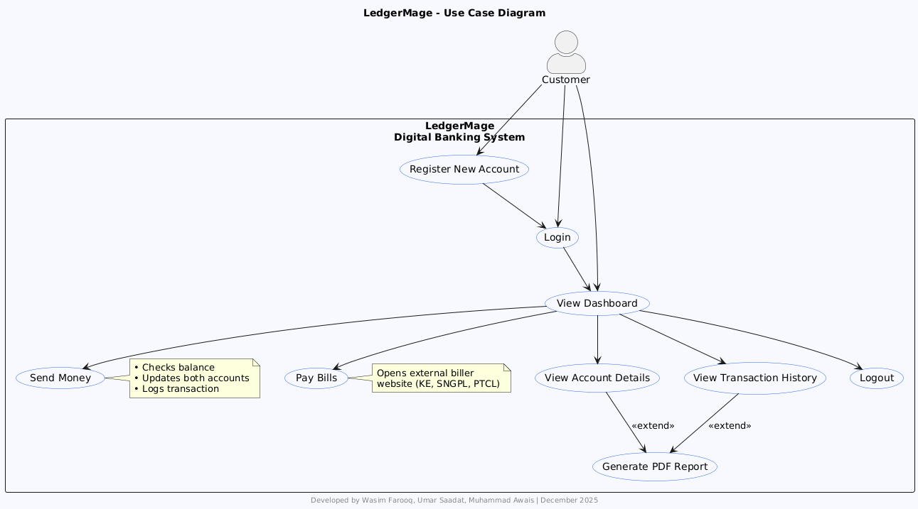

- EER Diagram

